**1. mkdir**

Make Directory

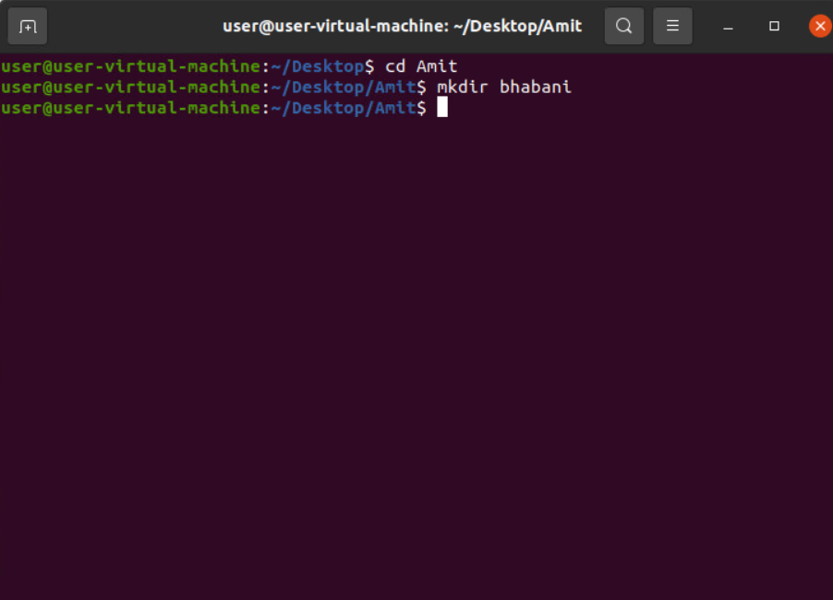

**2. mkdir “amit dash”**

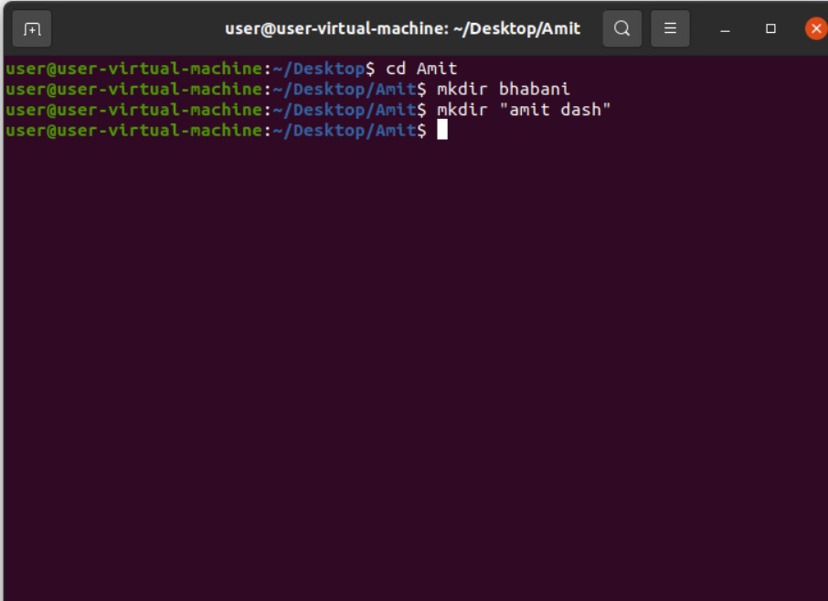

**3. rmdir**

Remove directory

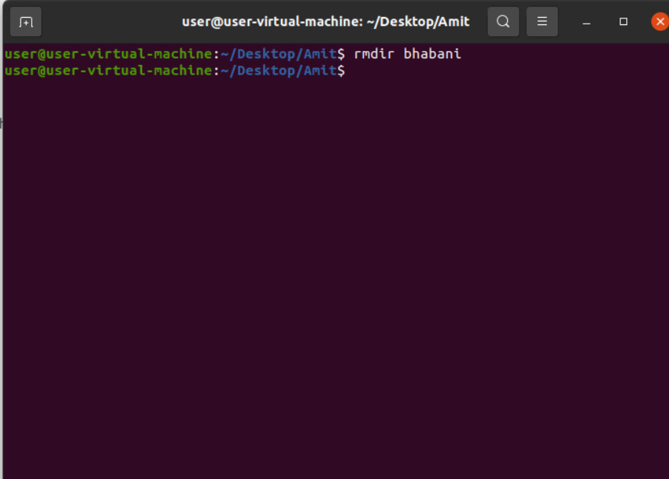

**4. rm**

Remove file

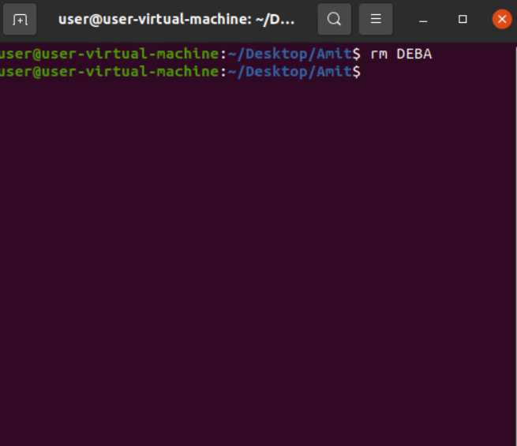

**5. mkdir -p “f1/f2/f3”**

subdirectories

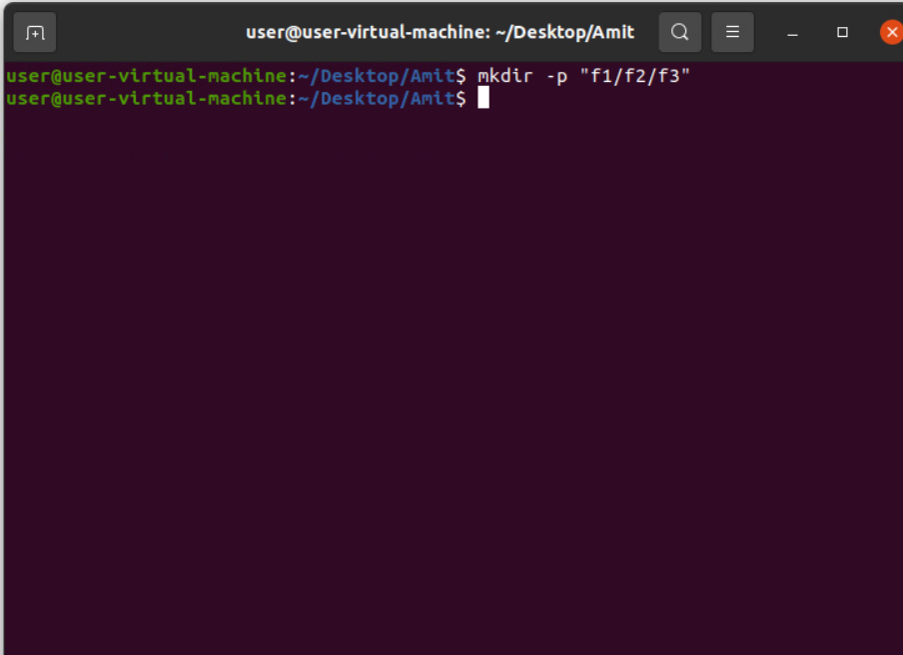

**6. mkdir {1..10}**

Create directories from 1-10

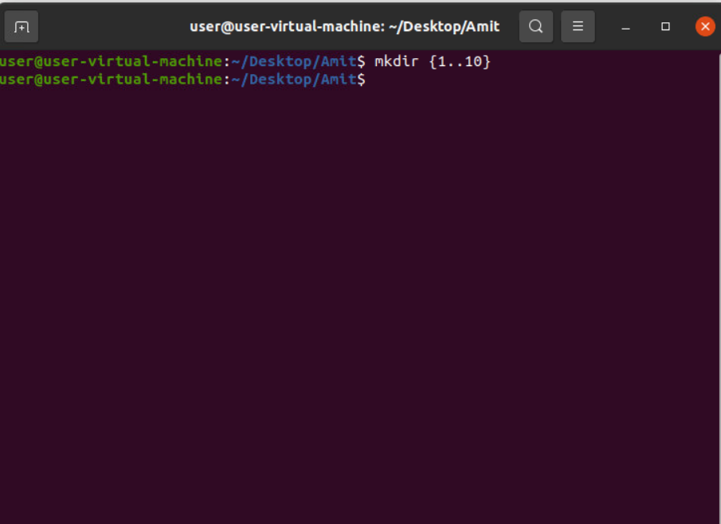

**7. mkdir folder{1..10}**

To create folder1 to folder 10

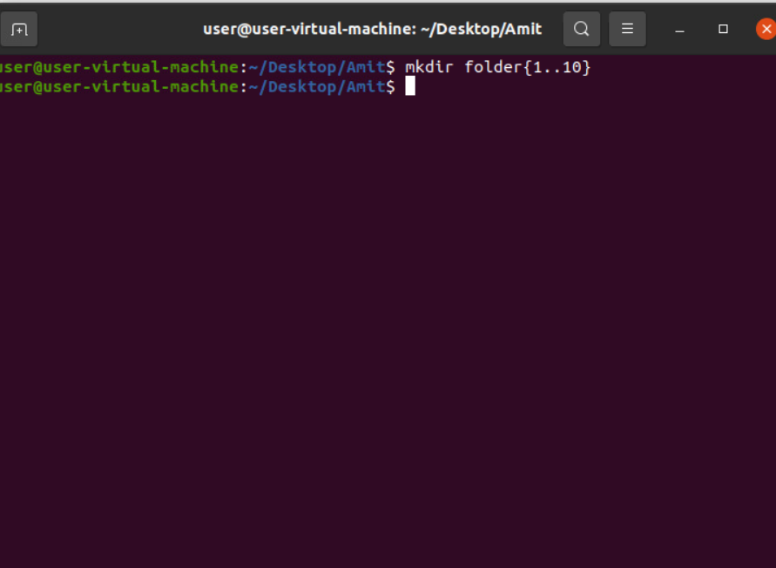

**8. rmdir {1..10}**

Remove directories from 1-10

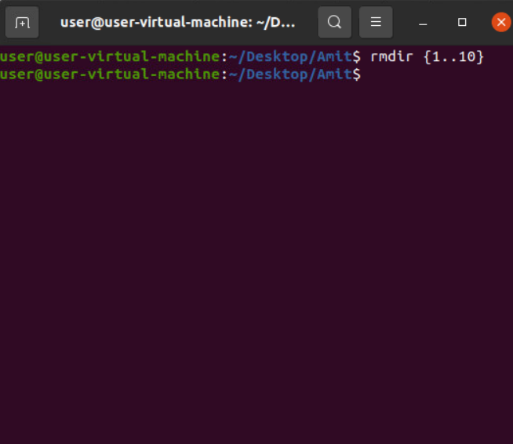

**9. rmdir folder{1..10}**

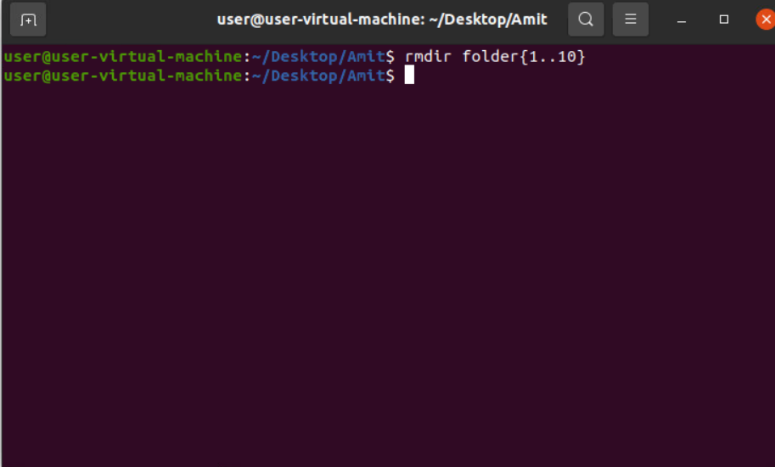

**10. rm -rf filename**

To delete the folder if it contains some data or subdirectories

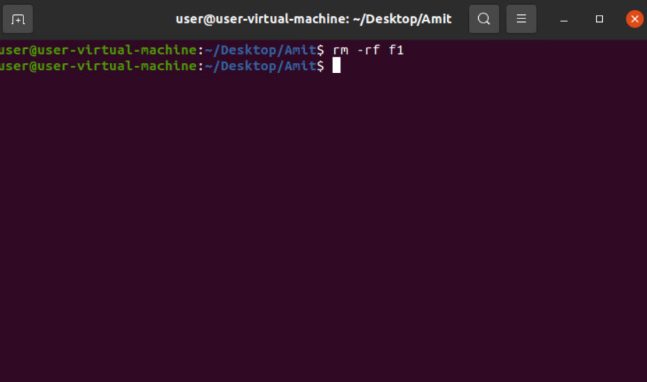

**11. touch**

To create a text file

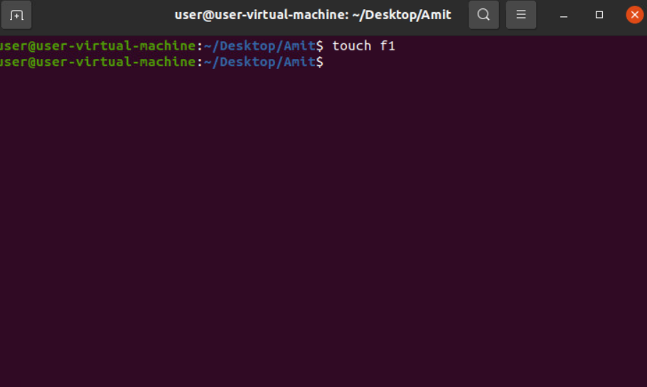

**12. touch -c filename**

 To check whether a file exists or not

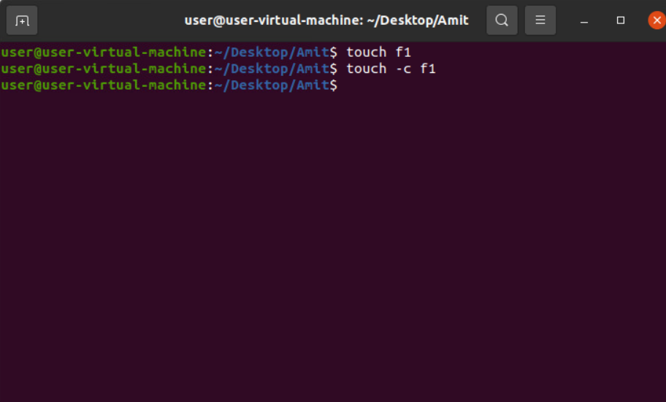

**13. touch file{1..100}**

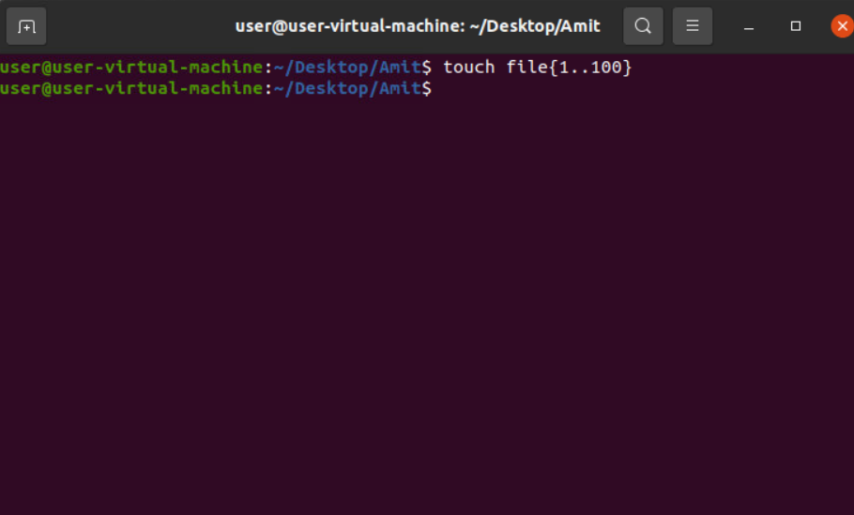

**14. rm \***

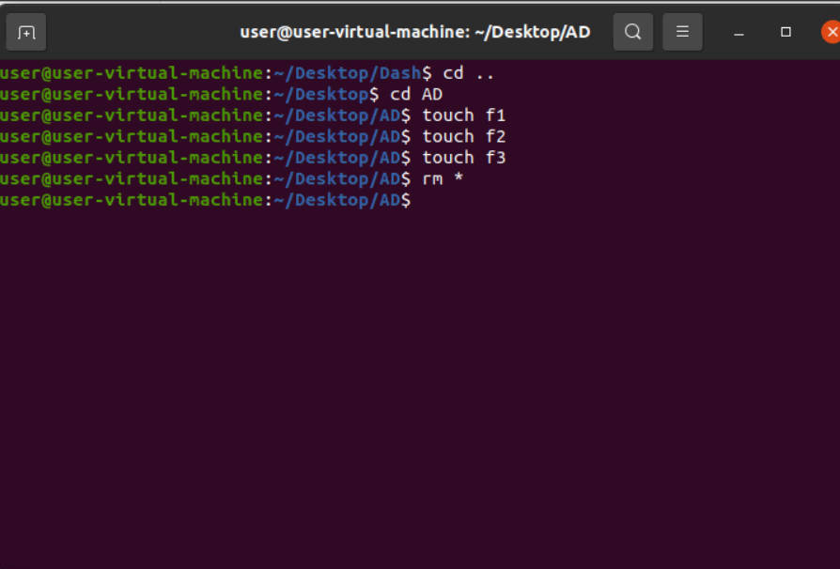

**15. cp file1 file 2**

To copy file1 into file2

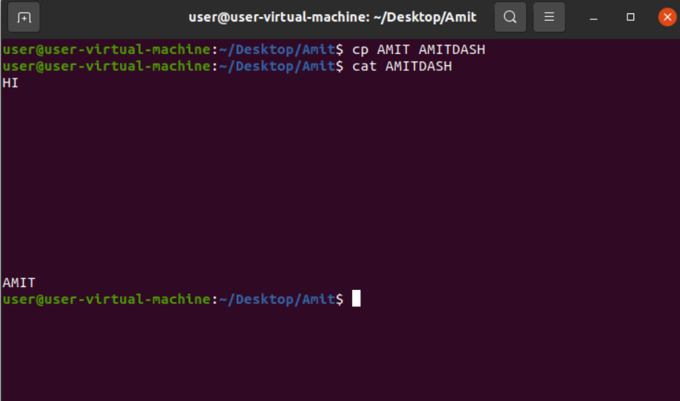

**16. cp -i file1 file2**

To overwrite the data if file2 contains something

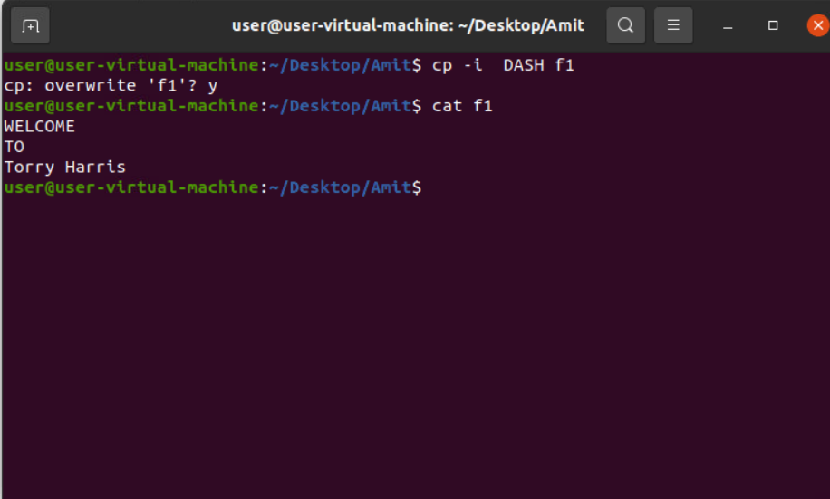

**17. cp -r folder1 folder2**

To copy folder1 into folder2

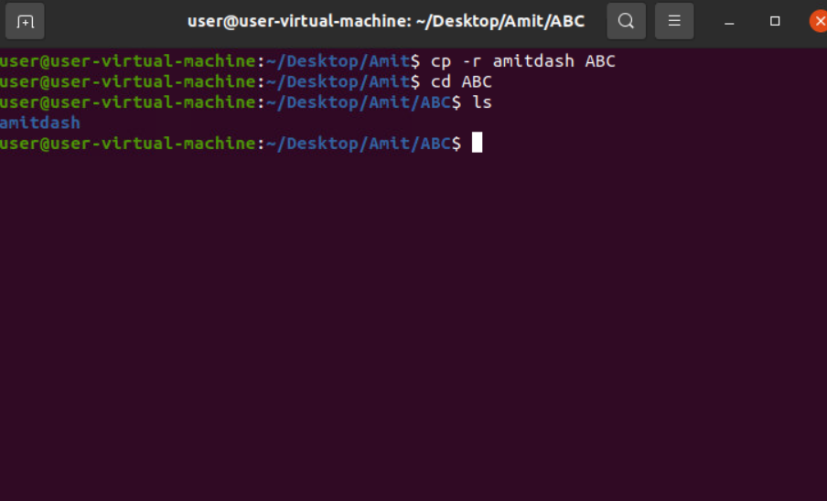

**18. mv *”../Amit/ABC”**

Move all the data to the destination directories

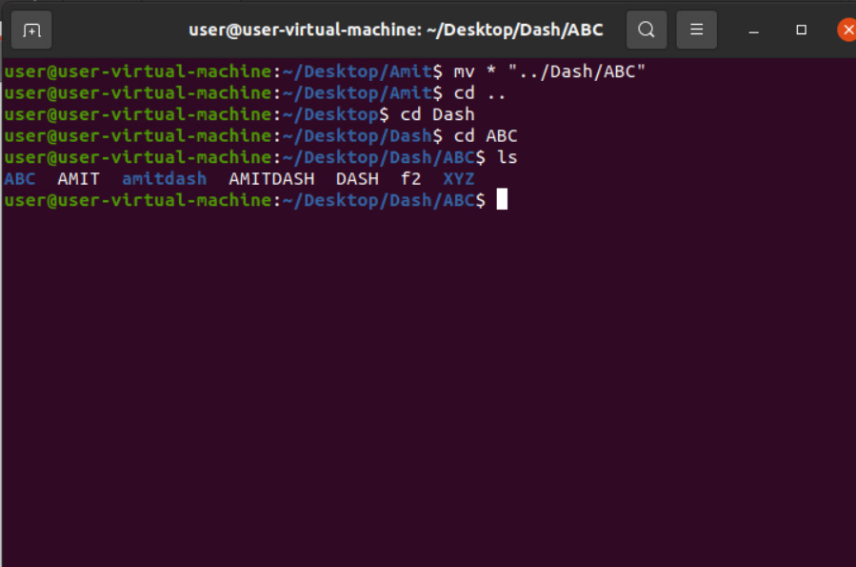

**19. mv file1 file2**

Move the data of file1 to file2 and also delete file1

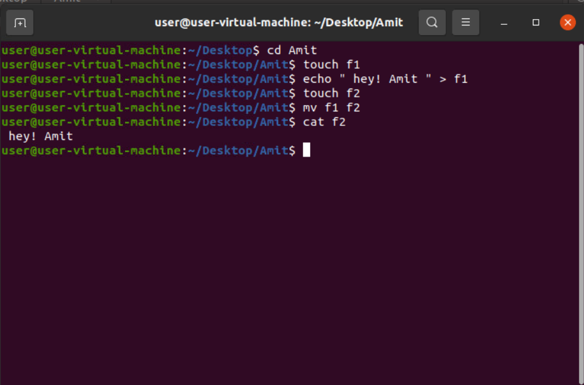

**20. sort file**

Sort according to dictionary manner

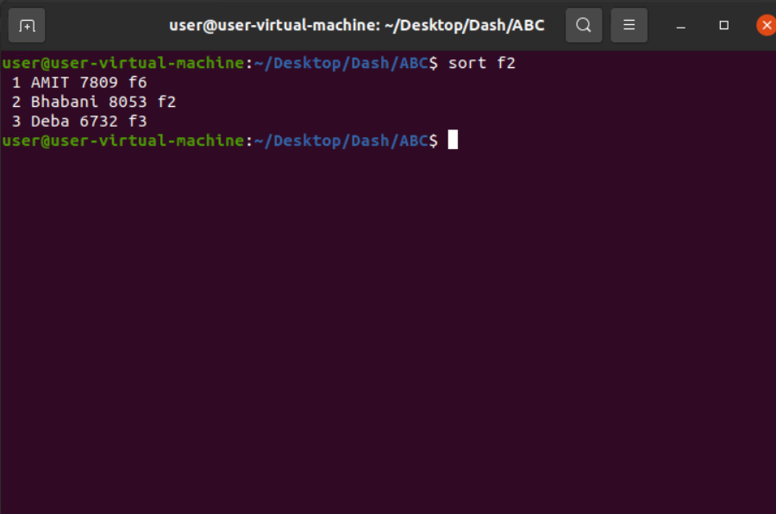

**21. sort file1>file2**

To store the sorted data of file1 in file2

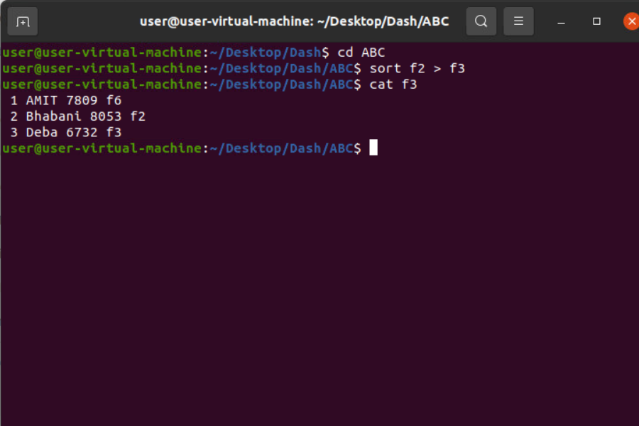

**22. sort -o sortedfile file**

To store the sorted data of file in sortedfile

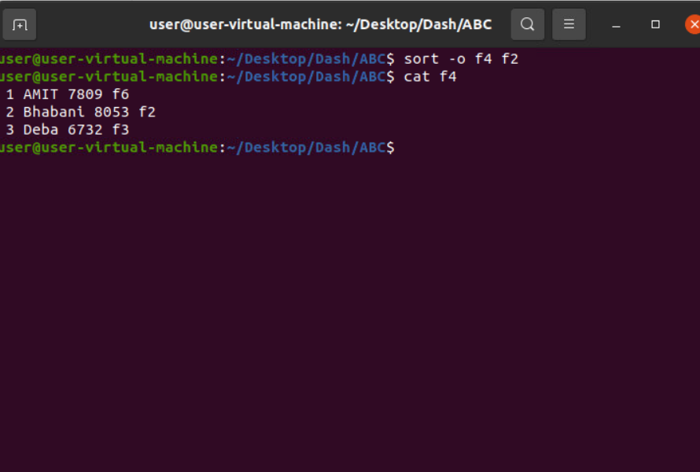

**23. sort -r file**

To sort data in reverse order

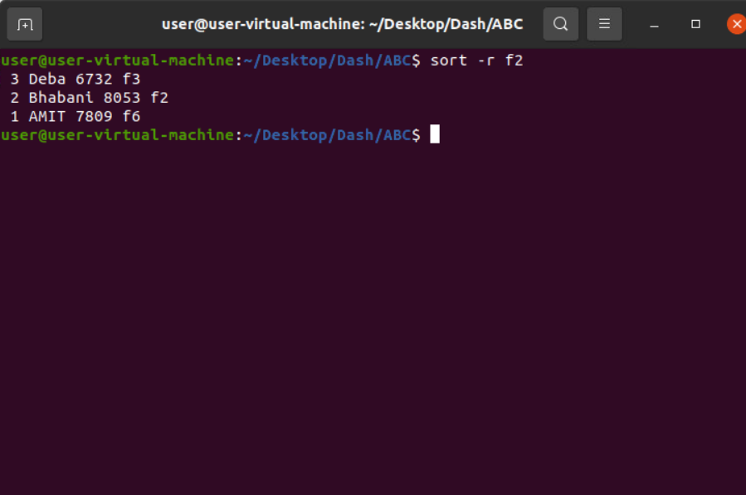

**24. sort -nr file**

To sort file in reverse number format

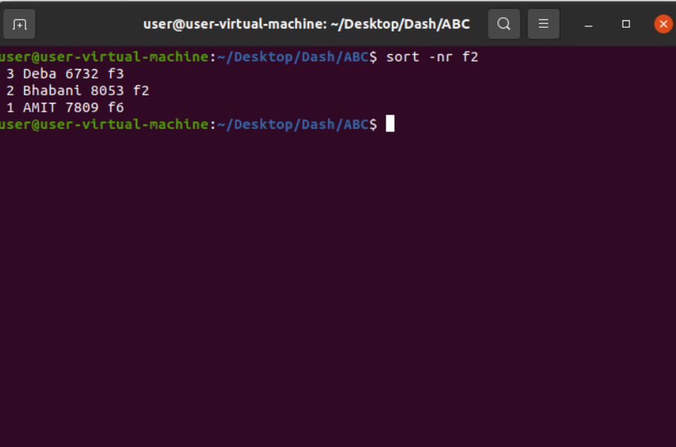

**25. sort -k3 file**

Sort the file according to column number

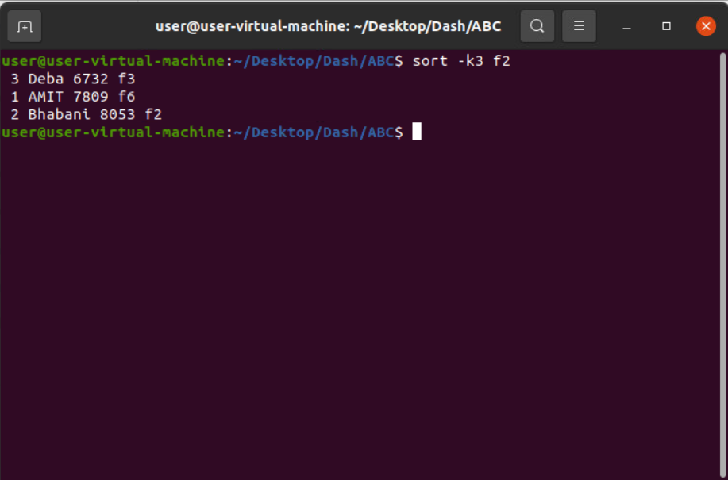

**26. sort -nk3 file**

Sort the file according to the value and also column number

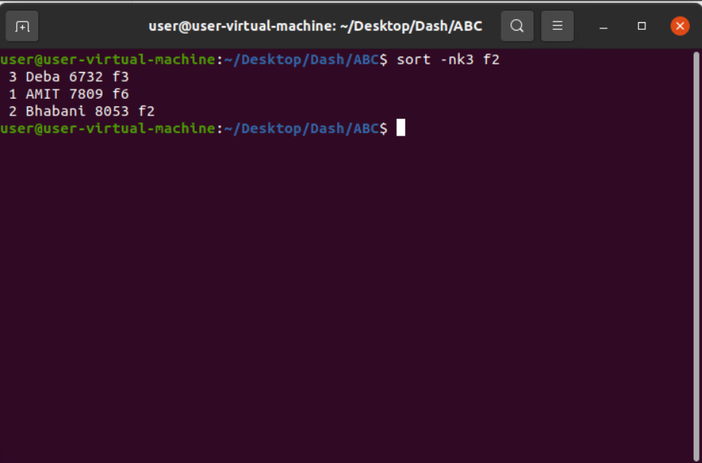

**27. sort -rnk3 file**

Sort the file in reverse order according to the value and also column number

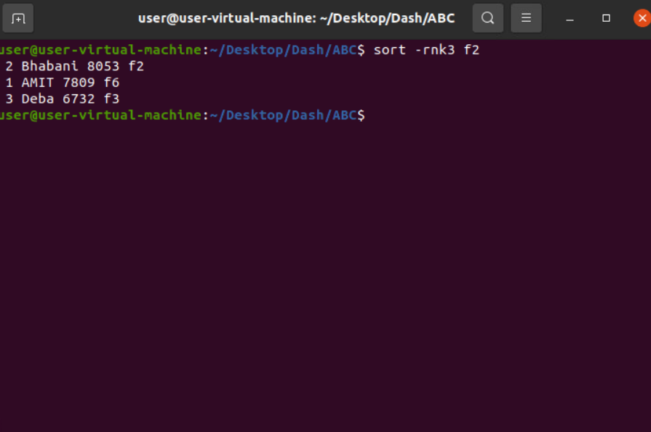

**28. sort -rk2 file**

To sort the file according to the column in reverse order

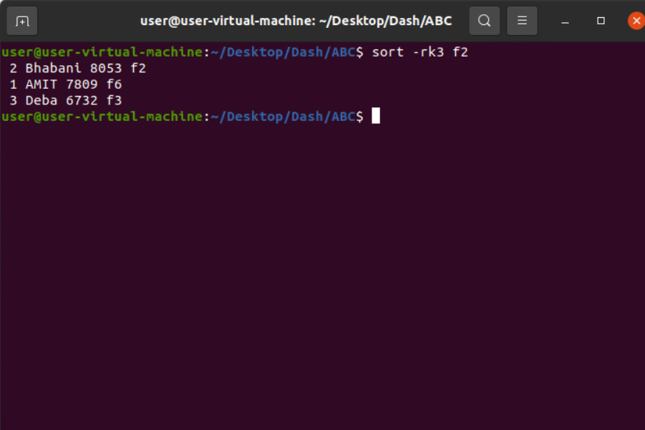

**29. date**

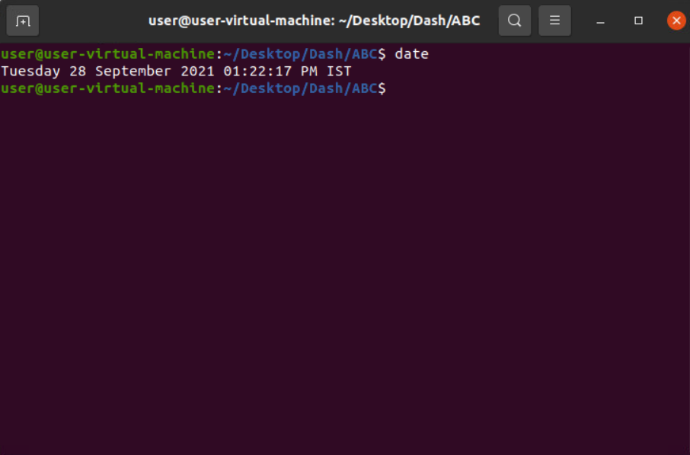

**30. cal**

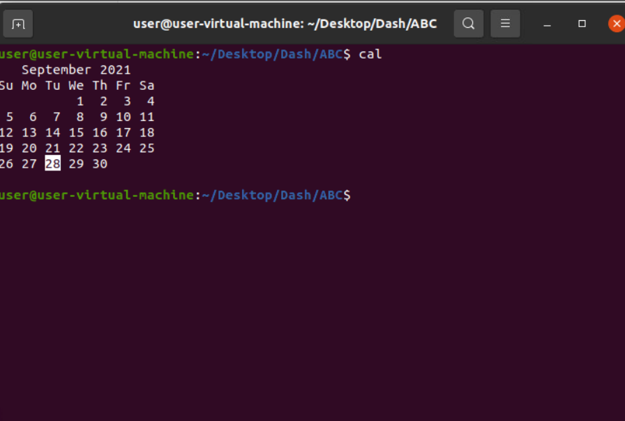

**31. sort -n file**

Sort according to numbers

